**Design User Interface**

**Main Page**

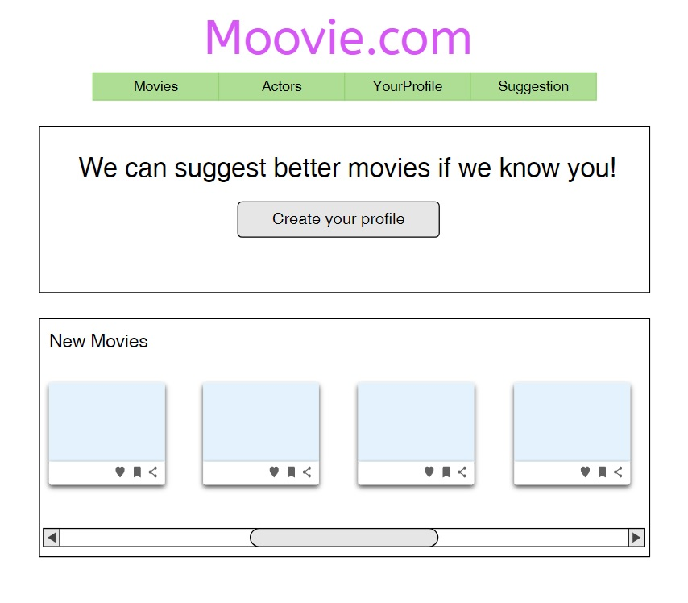

**Movie Page**

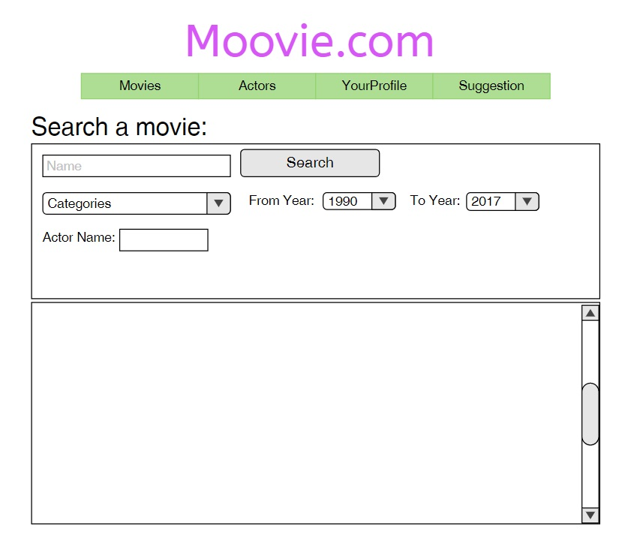

**Actors Page**

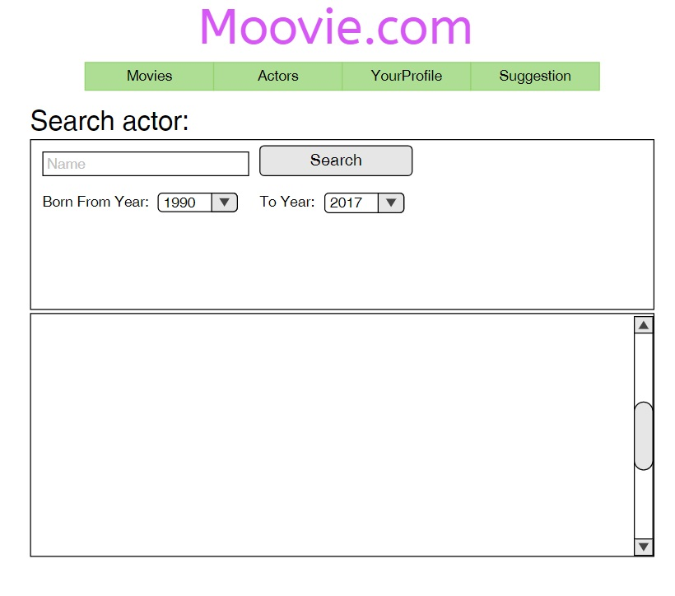

**Profile Page**

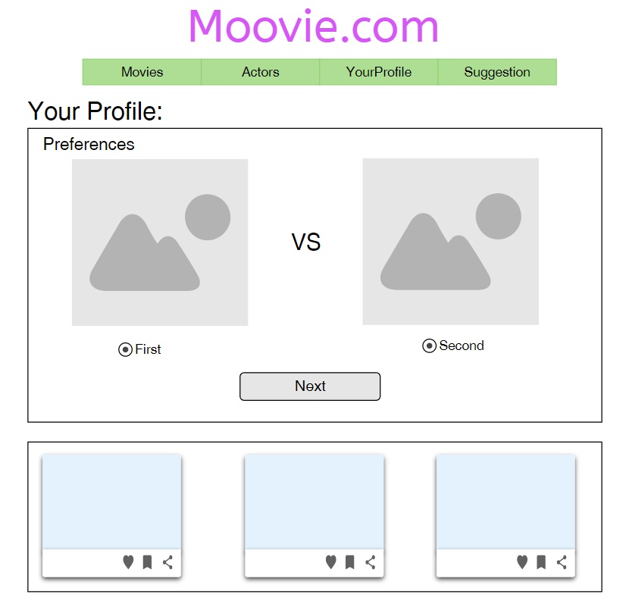

**Suggestion Page**

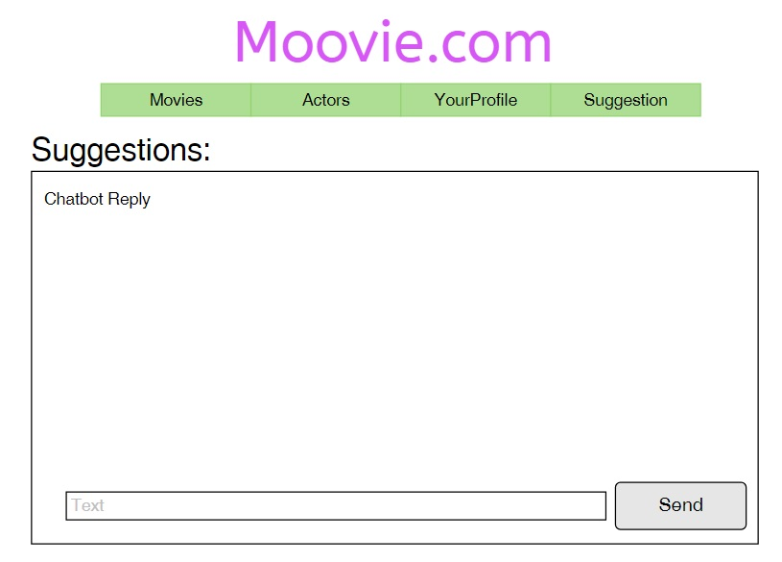

**Identify Components**

Movies Categories List

Movies Ranking List

Profile By Preferences Component

Movie Suggestion with chatbot (Beta version)

**Identify API Calls**

GET Categories/

GET Movie/SearchID=?

PUT UserProfile/:ID

GET Movie/SearchByActor=?

PUT MovieRank/:ID

GET Reply/text=?

**Define User Actions**

View All Movies

View Movies By Category

View Movies By Actors

Fill Profile Form for Automatic Movies Suggestions

Rank a movie